**Amazon Machine Image**

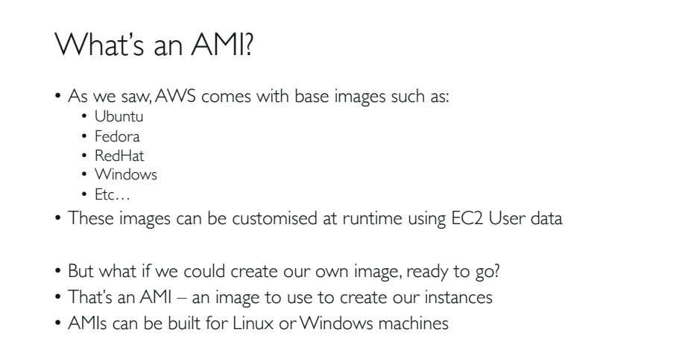

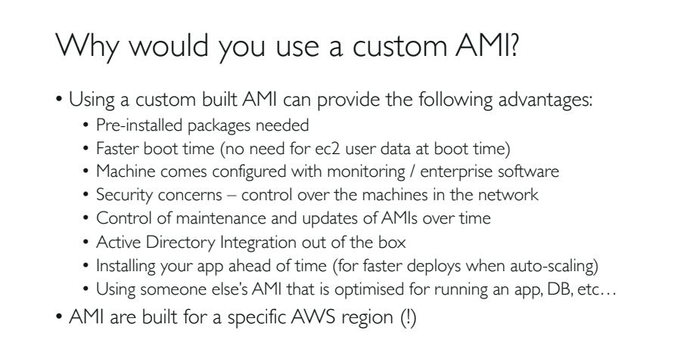

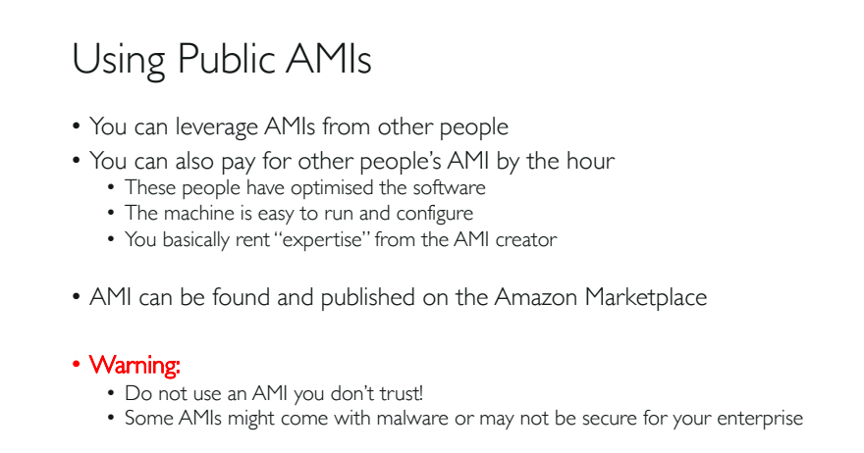

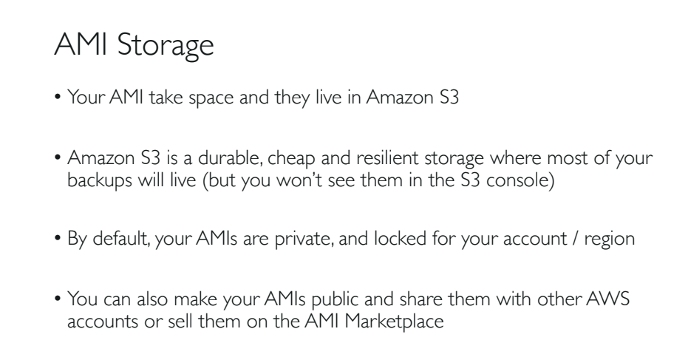

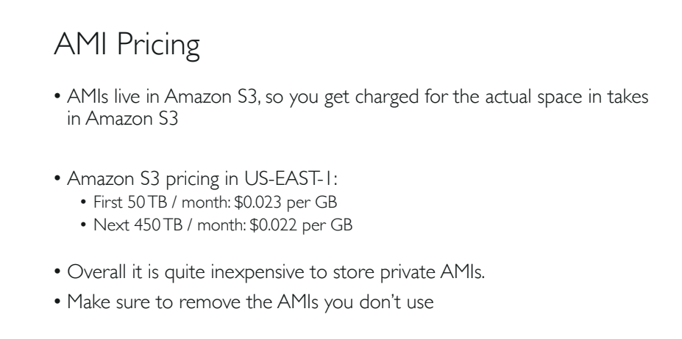

Creating AMI from an Instance:

1. Login to your EC2 console and connect to your Linux 2 server using ssh.
2. After logging into the console type the following commands.
   1. sudo su 🡪 To connect as a super user
   2. yum update -y 🡪 For updating installed packages
   3. yum install -y httpd 🡪 For installing apache web server
   4. systemctl start httpd 🡪 To start the web server
   5. systemctl enable httpd 🡪 To enable and run the apache web server
   6. echo “Hello world” > /var/www/html/index.html 🡪 Create an index.html file in the given location
   7. crul localhost:80 🡪 By default apache web server runs at port 80

Accessing the html file in Browser:

1. In order to avoid ‘timeout’ error, check whether you have added the port 80, in your Security Group>Inbound Rule.
2. After that copy the public ipv4 and paste it on browser url like the following at port 80: 13.232.158.68:80/image2.html

Creating and AMI or image from the modified Instance:

1. Since we have modified our instance by creating HTTPD in the instance, lets take an AMI or image from the modified instance.
2. Right click on the instance> image> create image.
3. Provide the details and create your image.

NOTE: While doing so, don’t forget to take the backup of the image by the location ‘/dev/xvda’.

1. It takes few minutes to create an image.
2. Go to ‘Images> AMI’s’ : It will turn from pending state to ‘available’ state.
3. Since the AMI is strictly region specific, we can copy the AMI to a different region.
4. We can modify the permission so that other people can see our AMI.
5. We can ‘Deregister’ it in case we want to remove the AMI.

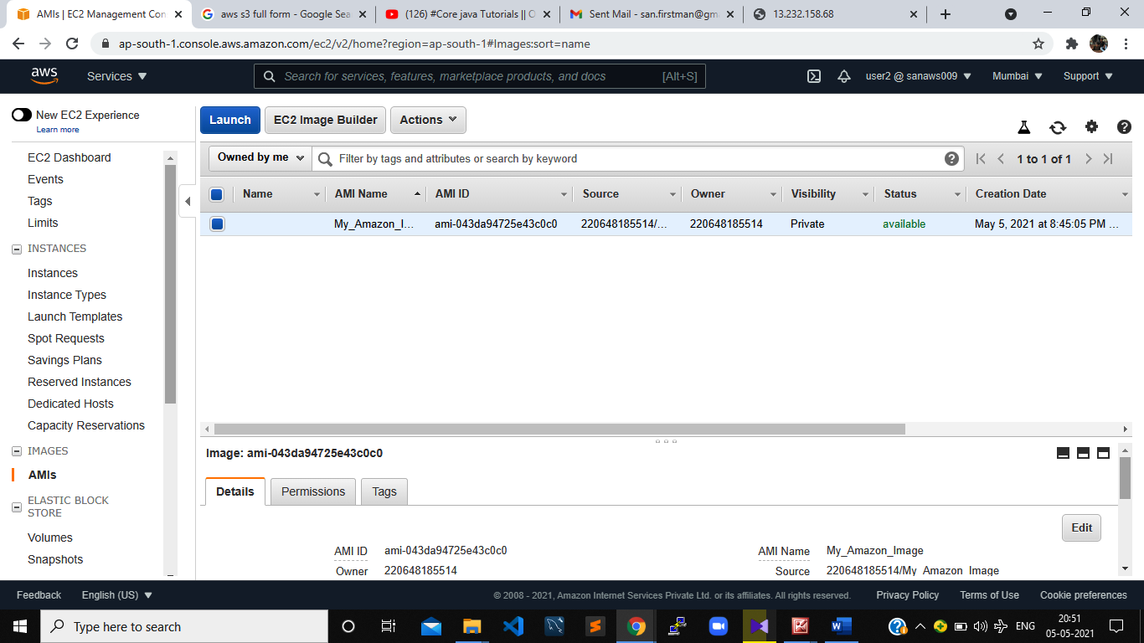

1. Right click on the new AMI and click ‘Launch Instance’

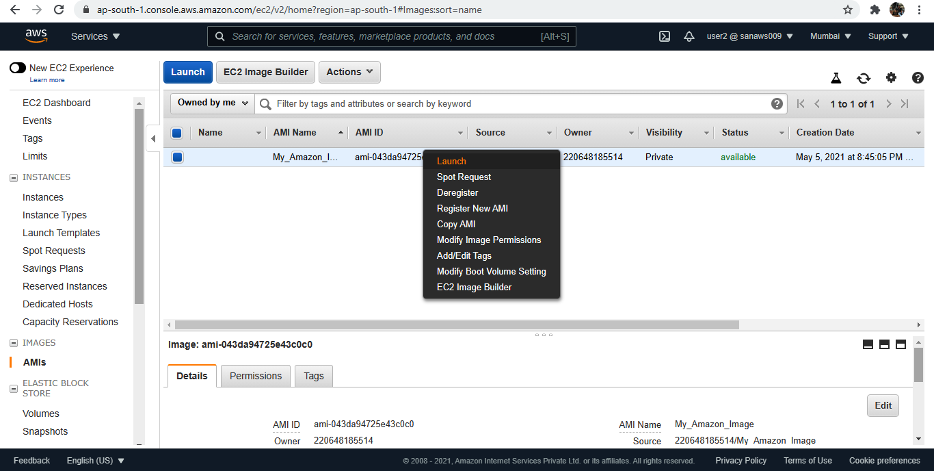

1. The new instance that we are launching is created based on the AMI that we have just created.

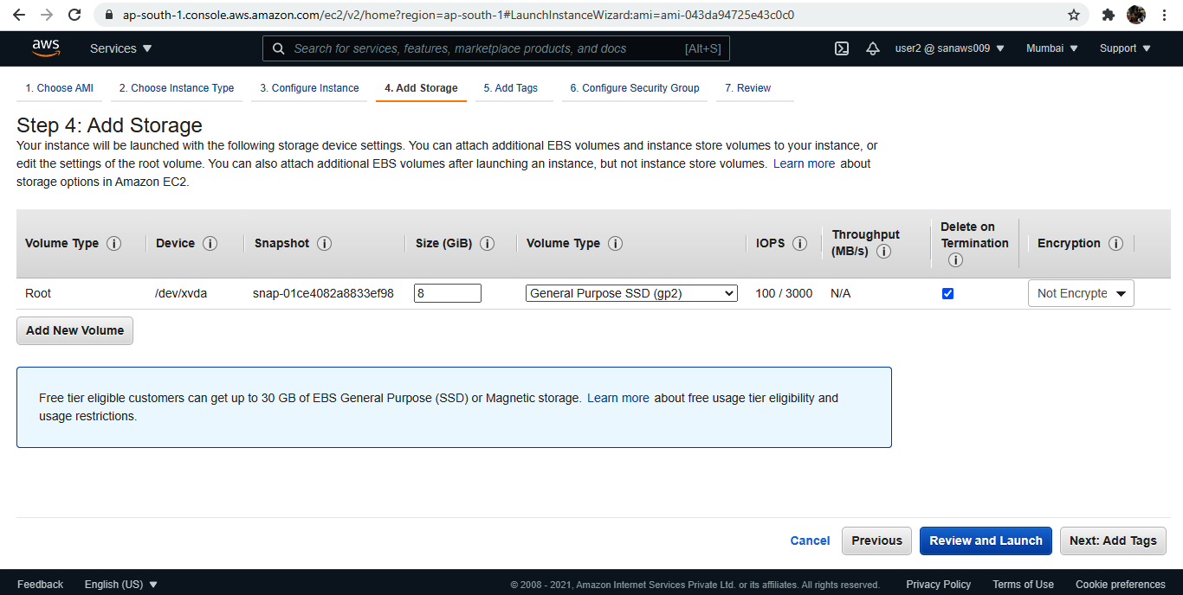

1. If you observe closely 🡪 see the root volume is coming from the snapshot column.
2. Create the instance.
3. Go to instances> and we can see there will be a new instance created which is an exact ‘snap shot’ of our pervious instance with httpd apache web server installed on it, and ready to use.
4. To prove this, copy the ipv4 of the new instance and run it on the browser.
5. You should see the ‘hello world’ message just like the previous instance.

NOTE: Make sure the ‘Security Groups’ are same.

NOTE: Such way we can setup software, security and lot more using AMI’s.